**Assignment 4.2**

Sample dataset to implement pig commands:

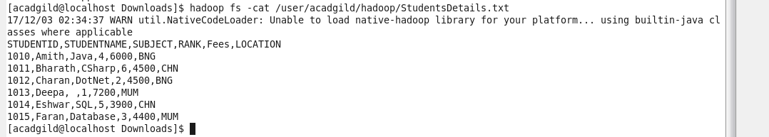

Copying Sample dataset from local to hdfs:



Loading sample dataset:





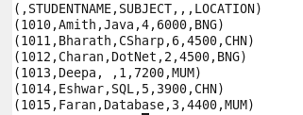

1. **Concat**

Concatenates two fields of type chararray or bytearray



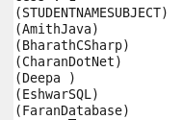

1. **Tokenize**



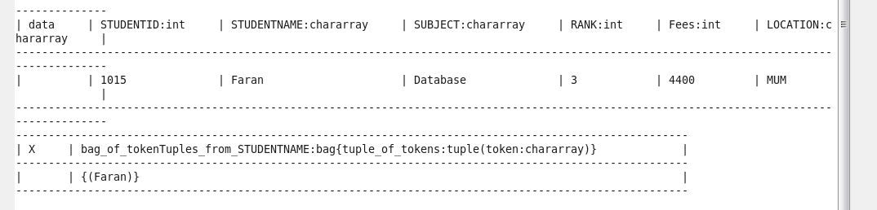

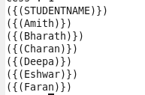

1. **SUM**

Computes the sum of the numeric values in a single-column bag. SUM requires a preceding GROUP ALL statement for global sums and a GROUP BY statement for group sums.



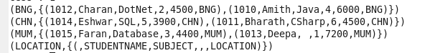



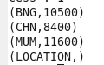

1. **MIN**

Computes the minimum of the numeric values or chararrays in a single-column bag.

MIN requires a preceding GROUP ALL statement for global minimums and a GROUP BY statement for group minimums.



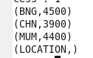

1. **MAX**



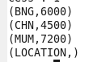

1. **LIMIT**





1. **STORE**

Stores or saves results to the file system



1. **Distinct**

Added few duplicate records in to a dataset

Using DISTINCT removes duplicate tuples in a relation





Only distinct tuples in a relation are displayed

